Online Food Ordering System
The Online Food Ordering System is a database-driven application designed to simplify the process of ordering food from restaurants. With the growing demand for online services, customers prefer the convenience of browsing menus, placing orders, and making payments digitally. Restaurants also benefit from efficient order management, improved customer reach, and reduced manual errors.
This system maintains and manages essential data such as:
- Users/Customers – who can register, log in, browse restaurants, view menus, and place orders.
- Restaurants – which provide details like restaurant name, location, and cuisine.
- Menu/Items – containing food categories, item names, prices, and availability.
- Orders – recording order details such as customer, restaurant, ordered items, quantity, price, total amount, and order status (Pending, Preparing, Delivered).
- OrderItems Table - acts as a junction between the Orders table and the MenuItems table.

Step 1 : Creating database
CREATE DATABASE OnlineFoodOrderingSystem;
Step 2 : Using Database
USE OnlineFoodOrderingSystem;

Problem Statements And Queries
Problem Statement :- The food ordering system needs to know the list of restaurants along with their ratings. This information helps customers compare restaurants and assists administrators in monitoring performance.
Q1 - List all restaurants with their ratings
SELECT name, rating FROM Restaurants;
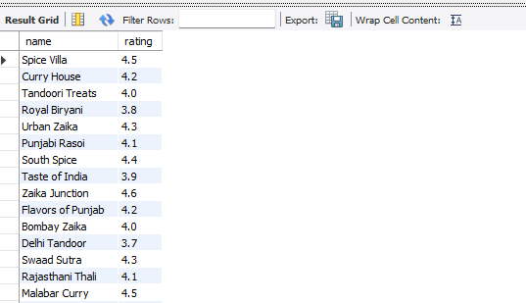

Problem Statement :- The food ordering system needs to display all menu items that are currently available along with their prices. This information helps customers view what items they can order in real time.
Q2 Show all available menu items
SELECT item_name, price FROM Menu WHERE is_available = TRUE;
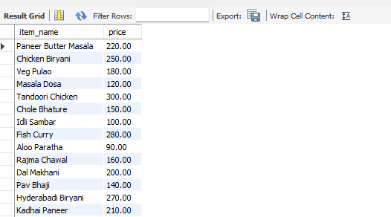
Problem Statement :- The food ordering system needs to track all orders placed by a specific user. This helps customers check their order history and allows the system to provide personalized support if needed.
-- Q3 Find all orders placed by a specific user
SELECT order_id, status, total_amount FROM Orders WHERE user_id = 5;
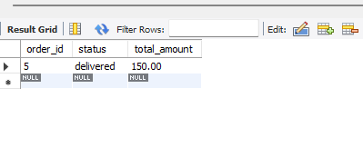

Problem Statement :- The food ordering system needs to fetch detailed information about a particular order, including items, quantity, and price. This helps customers review their order contents and assists restaurants in preparing the order accurately.
-- Q4 Get order details of a particular order
SELECT oi.order_item_id, m.item_name, oi.quantity, oi.price FROM OrderItems oi JOIN Menu m ON oi.item_id = m.item_id WHERE oi.order_id = 10;
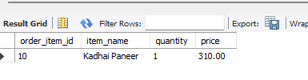
Problem Statement :- The food ordering system needs to list all restaurants along with the total number of menu items they offer. This helps in analyzing restaurant variety and provides customers with insights into menu availability.
-- Q5 List all restaurants with number of menu items
SELECT r.name AS restaurant, COUNT(m.item_id) AS total_items FROM Restaurants r LEFT JOIN Menu m ON r.restaurant_id = m.restaurant_id GROUP BY r.name;
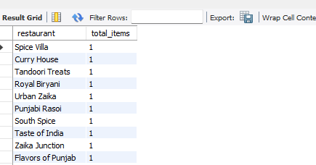

Problem Statement :- The food ordering system needs to calculate the total number of orders and the total amount spent by each customer. This helps in understanding customer purchase behavior and identifying loyal or high-value customers.
-- Q6 Find total orders and total spend of each customer
SELECT u.name, COUNT(o.order_id) AS total_orders, SUM(o.total_amount) AS total_spent FROM Users u JOIN Orders o ON u.user_id = o.user_id GROUP BY u.user_id, u.name;
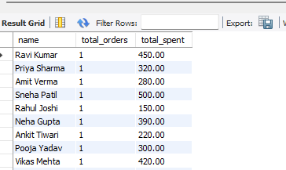
Problem Statement :- The food ordering system needs to identify the top 5 restaurants with the highest ratings. This helps customers quickly find the best-rated options and assists the platform in promoting high-performing restaurants.
Q7 Top 5 restaurants with highest rating
SELECT name, rating FROM Restaurants ORDER BY rating DESC LIMIT 5;
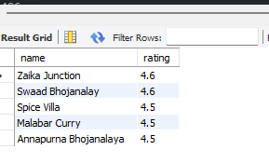
Problem Statement :- The food ordering system needs to display all orders along with their associated customer and restaurant details. This helps in tracking orders comprehensively and ensures better coordination between customers, restaurants, and the system.
-- Q8 Get all orders with their restaurant and customer details
SELECT o.order_id, u.name AS customer, r.name AS restaurant, o.status, o.total_amount FROM Orders o JOIN Users u ON o.user_id = u.user_id JOIN Restaurants r ON o.restaurant_id = r.restaurant_id;
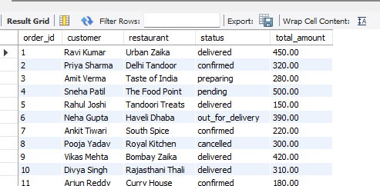

Problem Statement :- The food ordering system needs to identify the most frequently ordered menu item. This helps restaurants understand customer preferences and optimize their menu offerings.
Q9 Find the most ordered item
SELECT m.item_name, SUM(oi.quantity) AS total_sold FROM OrderItems oi JOIN Menu m ON oi.item_id = m.item_id GROUP BY m.item_name ORDER BY total_sold DESC LIMIT 1;
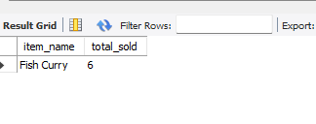
Problem Statement :- The food ordering system needs to find the top 3 customers based on their total spending. This helps in identifying high-value customers and designing loyalty or reward programs.
-- Q10 Find top 3 customers according to their money spend
SELECT u.name, SUM(o.total_amount) AS total_spent FROM Users u JOIN Orders o ON u.user_id = o.user_id GROUP BY u.user_id, u.name ORDER BY total_spent DESC LIMIT 3;
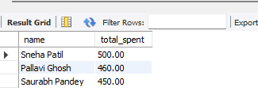

Problem Statement :- The food ordering system needs to calculate the average order value for each restaurant. This helps in evaluating restaurant performance and understanding customer spending patterns at different restaurants.
Q11 Find average order value per restaurant
SELECT r.name AS restaurant, AVG(o.total_amount) AS avg_order_value FROM Orders o JOIN Restaurants r ON o.restaurant_id = r.restaurant_id GROUP BY r.name;
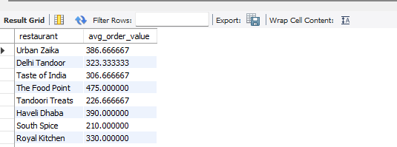
Problem Statement :- The food ordering system needs to identify menu items that have never been ordered. This helps restaurants review their menu, remove unpopular items, or promote them to increase sales.
-- Q12 Find menu items never ordered
SELECT m.item_name FROM Menu m LEFT JOIN OrderItems oi ON m.item_id = oi.item_id WHERE oi.item_id IS NULL;
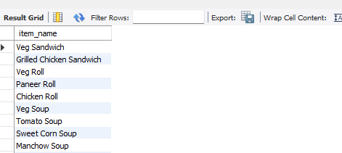
Problem Statement :- The food ordering system needs to calculate the total revenue generated by each restaurant from delivered orders. This helps restaurants track their earnings and assists the platform in analyzing overall business performance.
Q13 Show revenue generated by each restaurant
SELECT r.name AS restaurant, SUM(o.total_amount) AS revenue FROM Orders o JOIN Restaurants r ON o.restaurant_id = r.restaurant_id WHERE o.status = 'delivered' GROUP BY r.name ORDER BY revenue DESC;
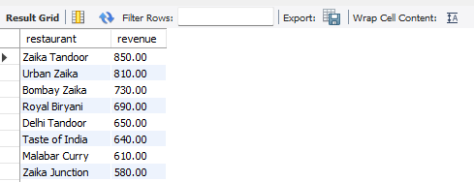
Problem Statement :- The food ordering system needs to list customers along with the total number of items they have ordered and their total spending. This helps in analyzing customer purchasing behavior and identifying the most valuable customers.

Q14List customers with the total number of items they ordered and total spend
SELECT u.user_id, u.name AS customer, SUM(oi.quantity) AS total_items_ordered, SUM(oi.price) AS total_spent FROM Users u JOIN Orders o ON u.user_id = o.user_id JOIN OrderItems oi ON o.order_id = oi.order_id
GROUP BY u.user_id,u.name ORDER BY total_spent DESC; 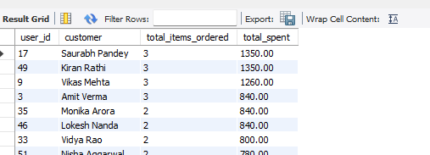
Problem Statement :- The food ordering system needs to find the top spending customer for each restaurant. This helps restaurants identify their most valuable customers and design personalized offers or loyalty rewards.

-- Q15 For each restaurant, find the top spending customer
SELECT r.name AS restaurant, u.name AS customer, SUM(o.total_amount) AS total_spent FROM Orders o JOIN Users u ON o.user_id = u.user_id
JOIN Restaurants r ON o.restaurant_id = r.restaurant_id
GROUP BY r.restaurant_id, r.name, u.user_id, u.name
HAVING SUM(o.total_amount) = (
SELECT MAX(t.total_spent)
FROM (
SELECT o2.restaurant_id, o2.user_id, SUM(o2.total_amount) AS total_spent
FROM Orders o2 GROUP BY o2.restaurant_id, o2.user_id
) t WHERE t.restaurant_id = r.restaurant_id );
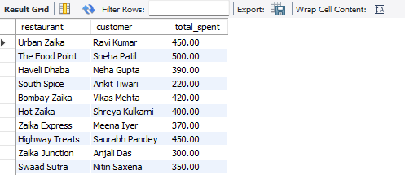

Problem Statement :- The food ordering system needs to identify orders where customers have ordered more than three unique items. This helps in analyzing large or bulk orders and understanding customer preferences for multiple-item purchases.
Q16 Find orders where the customer ordered more than 3 unique items
SELECT o.order_id, u.name AS customer, COUNT(DISTINCT oi.item_id) AS unique_items
FROM Orders o
JOIN Users u ON o.user_id = u.user_id
JOIN OrderItems oi ON o.order_id = oi.order_id
GROUP BY o.order_id, u.name
HAVING COUNT(DISTINCT oi.item_id) > 3;
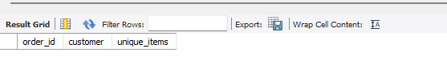
Problem Statement :- The food ordering system needs to identify the restaurant that has generated the highest revenue from delivered orders. This helps in recognizing top-performing restaurants and making strategic business decisions.
-- Q17Find the overall best restaurant (highest revenue generated)
SELECT r.name AS restaurant, SUM(o.total_amount) AS total_revenue
FROM Orders o
JOIN Restaurants r ON o.restaurant_id = r.restaurant_id
WHERE o.status = 'delivered'
GROUP BY r.name ORDER BY total_revenue DESC LIMIT 1;
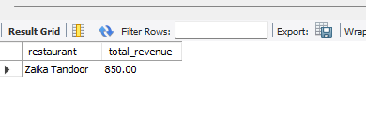

Problem Statement :- The food ordering system needs to identify the top 5 users who have ordered from the highest number of different restaurants. This helps in understanding customer diversity in restaurant preferences and targeting frequent platform users.
-- Q18 Find top 5 users who ordered from the highest number of different restaurants
SELECT u.name AS customer, COUNT(DISTINCT o.restaurant_id) AS unique_restaurants
FROM Users u
JOIN Orders o ON u.user_id = o.user_id
GROUP BY u.user_id, u.name
ORDER BY unique_restaurants DESC
LIMIT 5;
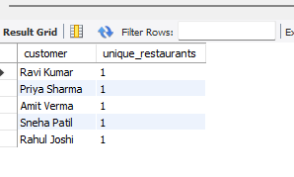
Conclusion
The Online Food Ordering System database project demonstrates the effective use of SQL to manage and analyze restaurant, menu, order, and customer data. By creating well-structured tables with proper relationships and constraints, the system ensures data integrity and easy retrieval of information.

